Discussion Guide – Collaborative Leadership
The Collaborative Leadership Assessment was built to help a pastor and his team consider how their parish already embodies the characteristics of Collaborative Leadership and to identify potential areas of growth.
After the pastor and 4-5 parish leaders have taken the assessment, we recommend that the group meet for 1.5 hours to pray and discuss the data. Print this worksheet as well as the results of the assessment to hand out.
Below are questions to help the team take actionable steps toward Collaborative Leadership, and on the back is a WRAP lectio template so that you can pray with your team for 15-20 minutes before discussion.
Review/Process the results:
- What areas of Collaborative Leadership are strong for our parish? What do you think we are doing that makes this area strong?
- What areas of Collaborative Leadership are opportunities for our parish? What do you think we are not doing that makes this area an opportunity?
- Look at the questions, “What seems most important and/or urgent to improve from this section on individual leadership development”. Were there any common answers? What do you think we are not doing that makes this an area in need of improvement?

Next Steps
- What is 1 small thing we can change immediately that will improve our collaborative leadership?
- What is 1 big thing we can work on over the next 3 months that will improve our collaborative leadership?
- Schedule a meeting in 1-2 months to review and recalibrate. Ask the team, did we complete the action items we said we would? Did completing them make a difference?
WRAP Yourself in Scripture
Journaling with Lectio Divina
Write the verse, phrase, or image that speaks to you.
1 Corinthians 12: 4-13
⁴Now there are varieties of gifts, but the same Spirit. ⁵And there are varieties of ministries, and the same Lord. ⁶There are varieties of effects, but the same God who works all things in all persons. ⁷But to each one is given the manifestation of the Spirit for the common good. ⁸For to one is given the word of wisdom through the Spirit, and to another the word of knowledge according to the same Spirit;⁹ to another faith by the same Spirit, and to another gifts of healing by the one Spirit, ¹⁰and to another the effecting of miracles, and to another prophecy, and to another the distinguishing of spirits, to another various kinds of tongues, and to another the interpretation of tongues. ¹¹But one and the same Spirit works all these things, distributing to each one individually just as He wills.
¹²For just as the body is one and yet has many parts, and all the parts of the body, though they are many, are one body, so also is Christ. ¹³For by one Spirit we were all baptized into one body, whether Jews or Greeks, whether slaves or free, and we were all made to drink of one Spirit.
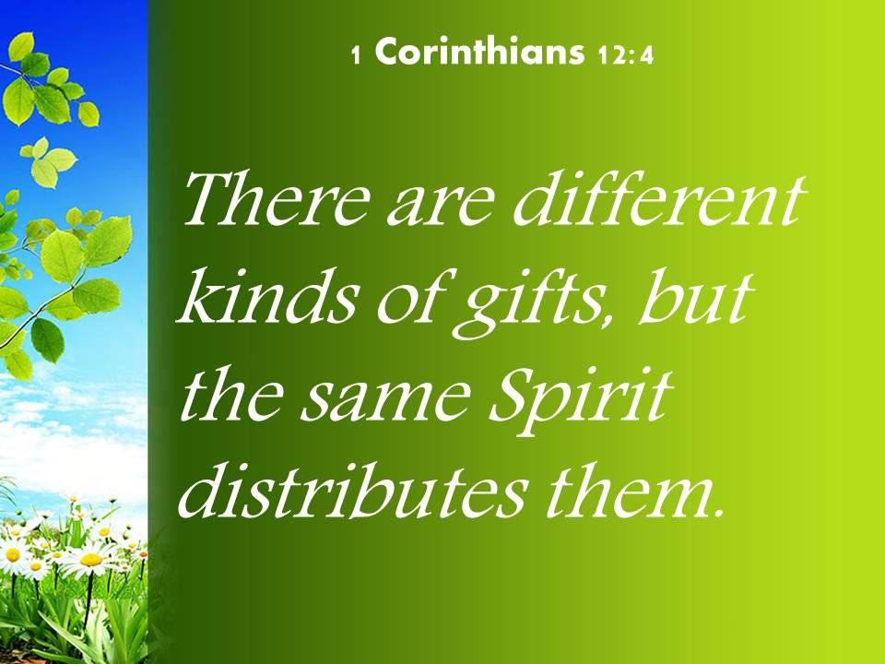

Pray Write a prayer related to these verses that offers praise & thanksgiving to the Lord. Ask God to help you respond in faith to His word. Focus on Jesus. Rest in His heart & presence.
Apply How is Jesus calling you to apply the truths from this Scripture? Write down your response to this Scripture & how you can apply it beginning today. Receive His strength, love, grace.
Reflect on the principle or truth that this Scripture is teaching. Write down what Jesus is speaking to your heart.

